 CO1035: Games Concepts
Assessment 1 Report
ID Number |  | Full Name

For each feature from the assessment brief listed in the table below, check its associated radio button if you have implemented the feature, or leave the radio button unchecked if you have not implemented the feature.

0 – 49 |  | 50 – 59 |  | 60 -69 |  | 70 - 100
Basic Scene | ☒ | Updated Camera | ☒ | Cube Model Array | ☒ | Randomised (Re)spawn | ☒
Sphere Movement | ☒ | Points | ☒ | Sphere to Box | ☒ | Hyper Mode | ☒
Camera Movement | ☒ | Scale Player | ☒ | GameWon State | ☒ | NPCs | ☒
Pause | ☒ |  |  |  |  | Points Ranking | ☒
Quit | ☒
Box Pickup | ☒
- Provide a state transition diagram to describe the behaviour of your game. (Paste an image in the box below)
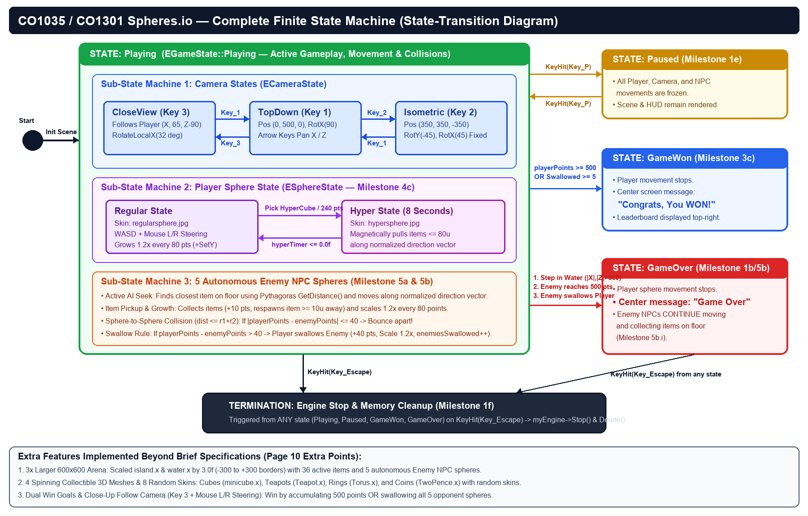
Additional / Extra Features Implemented (Milestone 5 Extra Points):
1. Expanded 600x600 Arena: Scaled island.x and water.x by 3x (-300 to +300 borders) with 36 active items and 5 autonomous Enemy NPC spheres.
2. Multiple Rotating 3D Collectible Meshes & Random Skins: Loaded minicube.x, Teapot.x, Torus.x, and TwoPence.x with 8 randomised texture skins.
3. Third-Person Close-Up Follow Camera (Key 3) & Mouse Button Steering: Added CloseView follow camera in addition to TopDown (Key 1) and Isometric (Key 2), plus Left/Right mouse button rotation.
4. Dual Win Condition & Live HUD: Player wins by accumulating 500 points OR swallowing all 5 opponent NPC spheres, with live on-screen ranking and Hyper Mode countdown timer.

